Naga charan
192211377
operating system

1.Create a new process by invoking the appropriate system call. Get the process identifier of the currently running process and its respective parent using system calls and display the same using a C program.

Program:

#include<stdio.h>
#include<unistd.h>
int main()
{
printf("Process ID: %d\n", getpid() );
printf("Parent Process ID: %d\n", getpid() );
return 0;
}

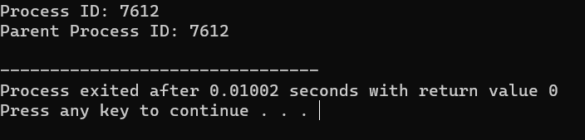
output:

